THE BENSINGTON SOCIETY

**Friday 31st May Meeting, Benson Parish Hall - Visitors Welcome**

**Doors open at 7pm for 7.30pm**

**Non-Members Entrance Fee £5**

**Supper £5 - Bar Available**

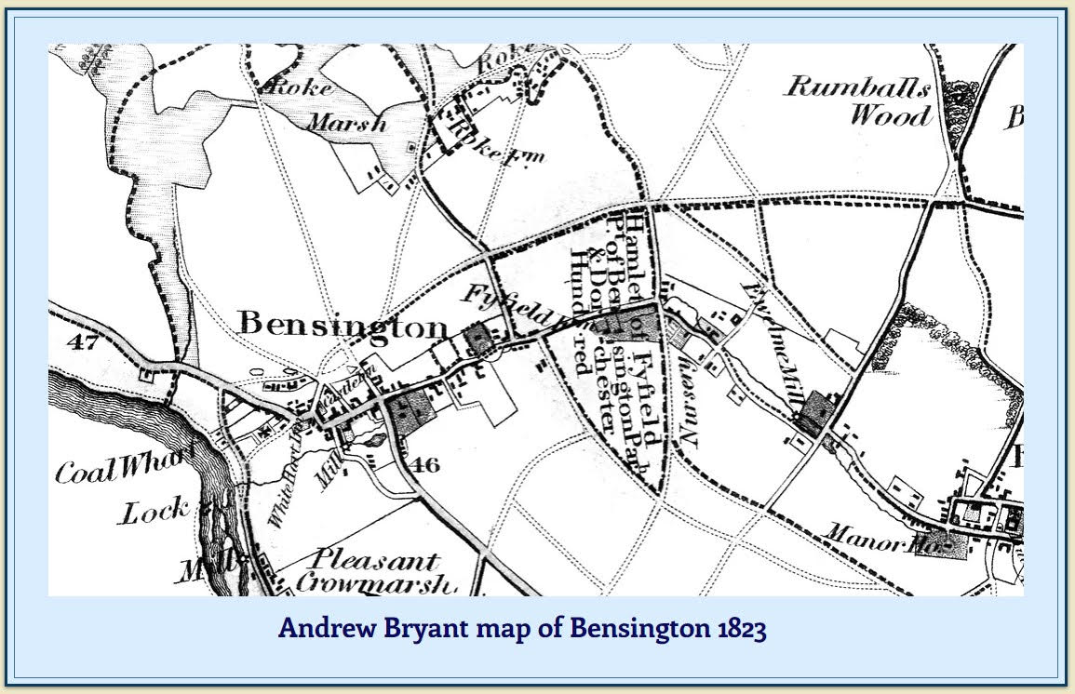

**PUTTING BENSON ON THE MAP : FROM GOUGH TO GOOGLE**

This talk is heavily illustrated with pictures of key printed maps that show Benson from 1574 onwards, with a brief introduction from prehistoric times up to primitive maps of Britain. It goes on to look at the significant revolutions in mapping in the 16th and 18th centuries, including the birth of the Ordnance Survey. It finally looks at the incredible transformation brought about by the digital age. Where would we be without our SatNavs?

**SPEAKER**

**John Leighfield CBE**

John was the Editor of the ‘Maps of Benson’ appendix in the Edith Ditmas’s ‘History of Benson’ (The “green” book about Benson published by The Bensington Society in 2009). His career has been in IT since the pioneering days of 1962 and he has been Chairman of a number of IT companies. He has been collecting maps of Oxford, Oxfordshire and adjoining counties and of Cornwall since 1966 and is a sought-after speaker on the subject.